**Documentation on Deploying Web Application on AWS Cloudfront**

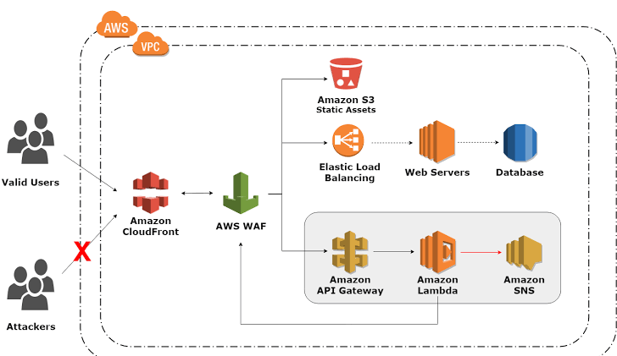

In this project documentation, we will be creating a web application on AWS cloud front that has been using CI/CD pipeline implemented on it. Where we have using such services Amazon cloud front, S3 bucket for static website hosting and we will be using a Terraform to creating an Infrastructure.

* Creation of AWS resources, security groups using web, instance.
* Internet gateway, VPC creation, subnets
* IAM roles and policies.
* Autos calling services role has attached policy to managing EC2 instance, load balancer.
* Load balancer have some target groups where we have to attached EC2 instance.
* Elastic load balancer to handle HTTP requests to web server, load balancer comes into the process.
* We were using Code deploy to ensure that code has been deployed on server and codepipleine build with code build and deploy on code deploy.